Computer Network Lab – 02
Muhammad Rehan | BSDSF22A001

- Managing a New Employee's Account
- sudo useradd -m Alex
- sudo passwd Alex
- sudo groupadd develepors
- sudo usermod -aG develepors Alex
- cat /etc/passwd | grep Alex
- groups Alex
- cat /etc/passwd
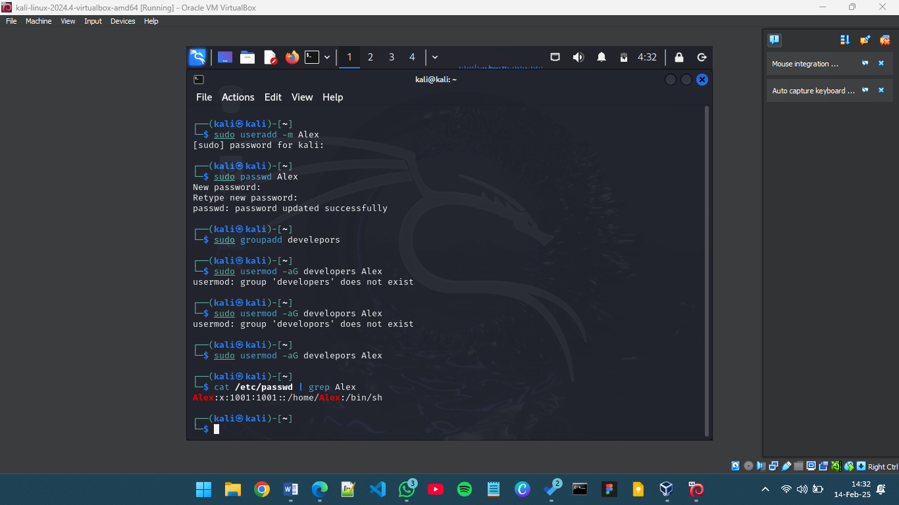

- Troubleshooting Network Issues
- ifconfig
- sudo systemctl restart networking
- sudo netstat -tulnp
- sudo iptables -L
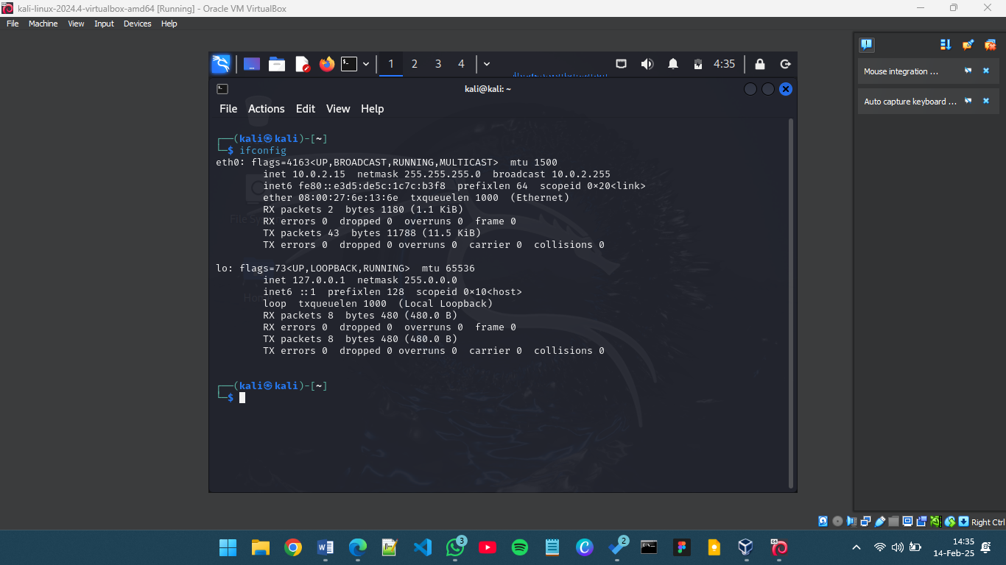
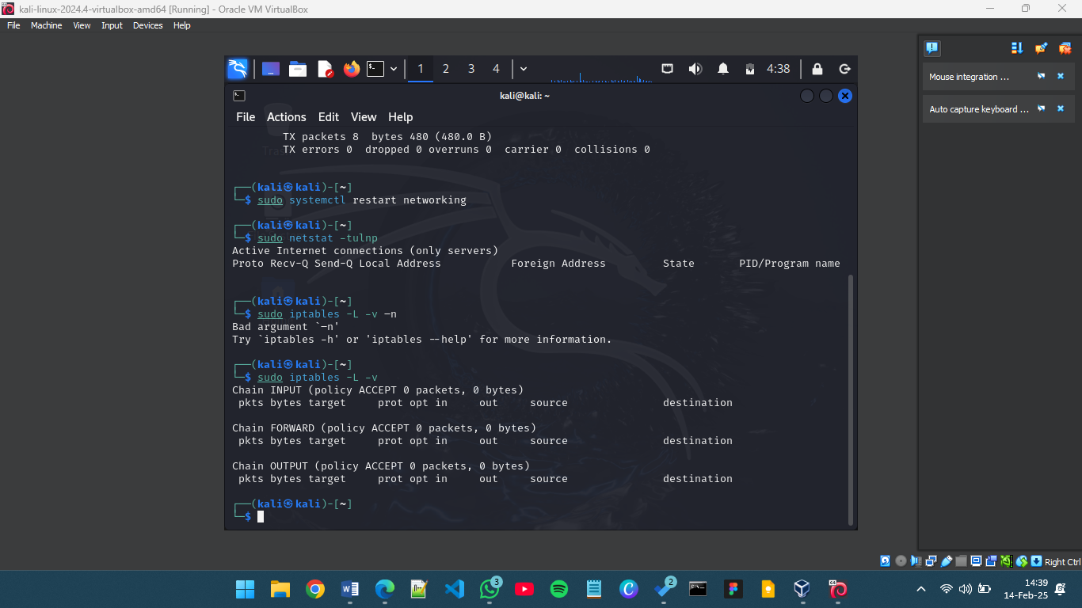
- Securing a User Account
- sudo usermod -L Alex
- sudo find / -user Alex 2>/dev/null
- sudo gpasswd -d Alex develepors
- sudo userdel -r Alex
- cat /etc/passwd | grep Alex
